

**TRAIN TICKETING SYSTEM**

**BY**

**IGNATIOUS MUGWAGWA: P1692551K**

A RESEARCH PROJECT SUBMITTED IN PARTIAL FUFILMENT OF THE BACHELOR OF INFORMATION TECHNOLOGY

2018

## **Table of contents**

Chapter 1

## Abstract

## List of Figures

## Introduction

## Organisational Background

## Problem Statement

## Project Aim

## Objectives

## Feasibility and Planning

## Justification of the Study

## Business value

## Feasibility Study (Operational, Technical and Economic)

## Risky Analysis

## Stakeholder Analysis

## Work Plan

# Chapter 2 Systems Analysis

## Data gathering methodologies employed

## Description of existing system

## Activity diagram

## DFD (Context and detailed)

## Weakness of existing system

## Justification of alternative taken

## Requirements Analysis (Use Case Diagrams)

# Chapter 3 System Design

## Proposed systems DFDs (Context and Detailed)

## Architectural design

## Menu Design

## Input design

## Output design

## Process design (Pseudo code, Flow charts)

## Database design (DD, ER and EER diagrams)

## Program design (Class, sequence, collaboration, package)

## Test data design

## Security and Backup design

## Test data design

## Deployment diagram

# Chapter 4 System Implementation

## Testing plan/Evaluation/Verification

## Installation and conversion

## Conversion method used in the system implementation

# Chapter 5 Conclusion and Recommendations

**Chapter 1**

**Abstract**

The basis of the proposed project is to develop a automated train ticketing system which enables the National Railways of Zimbabwe to provide ticketing services to the passengers through a user friendly server based desktop application. This proposed system aims at eliminating the practice of time consuming and vulnerable tradition of manual ticketing system of train tickets in paper at the very basic level. At the National Railways of Zimbabwe there are many departments all these departments provide various records regarding ticketing system. Most of these track records need to maintain information about the ticketing process. Thus by proposing a computerized Train ticketing system will enable the Service provider to access data at any time and also ease the tracking of transactions records. The Train ticketing system enables huge storage of data and easy retrieval. There are many departments in at National Railways of Zimbabwe thus by introducing a Train ticketing system will centralize the administration and the entire system will work as one single entity. The paper work would be reduced and time taken when serving clients will be reduced due to the use of a computerised train ticketing system. Train ticketing desktop application system is easy to use and also helps the service provider to monitor and keep track of transactions. aim of case study is to design and develop a database maintaining the records of train ticketing transactions, payment status and passenger details. The system will be developed using C# (Sharp) as front end framework and MySQL as backend. The system intends to provide and improve the smooth flow and efficient train ticketing process and also be able to produce and stored transactions records for easier decision making.

* 1. **Introduction**

In this technological era every business need to transform from the old systems of serving client to a new and efficient system to enable efficiency in the business operation that is the Train ticketing system need to be upgraded to cater for the change in rise in demand of the transportation services. Train ticketing system is developed for daily ticketing process at the National Railways of Zimbabwe stations**.**

The system will facilitate access to transaction information of a particular teller any time by the system administrator and other related departments supervisors. The purpose of developing Train ticketing system is to computerized the tradition way of producing tickets to the passengers. Another purpose for developing this software is to enable ease of tracking of transaction records The scope of the project is the system on which the software is installed that is the project is developed as a desktop application, and it will work for National Railways of Zimbabwe.

.

* 1. **Organisational Background**

The National Railways of Zimbabwe (NRZ) is the parastatal railway of Zimbabwe (formerly Rhodesia). The National Railways of Zimbabwe (NRZ) is mainly based in Bulawayo and Harare but have other substations in other city in Zimbabwe. The Zimbabwean railway system was largely constructed during the time of British colonial rule and was called Rhodesia Railways (RR) until 1980. Segments of its systems were intended to be part of the Cape to Cairo Railway. NRZ operates about 3,400 km (2,100 miles) of railway lines, all of 3 ft 6 in (1,067 mm) providing passenger and freight services.

The gauge is standard for all of southern Africa. NRZ has an important transit function in the southern part of Africa and is well linked with neighboring countries toward the north, at Victoria Falls the system links to the Zambia Railways, crossing the Victoria Falls Bridge. Toward the Indian ocean the system links to the Beira Railroad Corporation in Mozambique. A second line toward Mozambique reaches Maputo.

To the west, a connecting line link ups to Botswana Railways to reach South Africa, eventually reaching Durban and Cape Town. A direct line to South Africa from Bulawayo was opened in 1999 by the Beitbridge Bulawayo Railway. The 313 km (194-mile) Gweru-Harare section is electrified at 25 kV AC. However the National Railways of Zimbabwe since 1980 has been doing the ticketing process using the book ticketing system although they later on adopted the online reservation ticketing system. These ticketing system have resulted in the failure to manage the financial records of the transactions that could have been occurring thus with the use of a desktop based ticketing system it enables the reduce the problem of archiving records and also tracking of transactions.

## **Problem Statement**

Modern transportation companies for example NRZ need speed and accuracy in serving their clients. This cannot be achieved by the current manual and online ticketing system that is, for example the traditional ticketing system which is done using books. This current manual system is becoming absolute and time consuming since it only requires more manual work in serving the client and also the use of the online ticketing system by the NRZ is difficult to other customers since they cannot access the internet due to absence of services in their areas and also some of the clients are not literate to use the internet to order travelling tickets. Also to add on the current system have some critical issues in terms of accountability that is the book ticketing system.

Thus by introducing a teller based desktop ticketing system it will be able to cater for these challenges that are currently being faced by the NRZ since they will be able to track each and every transaction that might have occurred and also it enables to cater for those passengers who do not have access to online ticketing system. The current manual system have a problem of delaying clients to and from work since they are forced to wait in long ques for purchasing travelling tickets using the book ticketing system. Adding on the online ticketing system have got a problem in that not all user can access the internet service to order tickets and also it requires many procedures.

## **Project Aim**

This project aims at producing a working Train Ticketing System that will be implemented by National Railways of Zimbabwe to cater for crisis that are being faced in terms of serving clients in their organizations. In addition to that this project aims at up bringing the ability of the train transportation service providers to reduce long ques since customers will make payments in many ways for example paying using mobile money and Swiping.

Adding on this Train Ticketing System aims to be cost effective and to reduce work load to the workers by replacing the book ticketing system with a computerized one. Lastly the aim of this project is to came up with a simple working Train Ticketing System that is easy to maintain and also a system that is easy to work with, when doing business which built efficiency in doing business.

## **Objectives**

* To convert manual work into computerized so that the load of employees can be reduced.
* To enable storing of data in computerized database rather than in registers and or book database.
* To create a system that will also be able to capture data and be able to print a receipt.
* To create a system that must be able to calculate estimated cost to be travelled by a passenger.
* To design a Train ticketing system in such a way that enhances tracking of transactions by senior manager and or by the administrator management.
* To design a Train ticketing system in such a way that it reduces time taken when serving clients or passengers.

## **Feasibility and Planning**

A Feasibility study and planning helps to objectively decide whether to proceed with a proposed project. A Feasibility Study have broad considerations when considering whether to undertake a new project. Based on the information presented in this feasibility study, it is recommended that NRZ approves the Train Ticketing System initiative and begins project initiation. The findings of this feasibility study show that this initiative will be highly beneficial to the organization and has a high probability of success.

The Train ticketing system will be a localised system which automates the train ticketing process and also tracking and monitoring of transaction records by system administrator. The system will have a decentralised control in such a way that all the substations of National Railways of Zimbabwe will have control over there transaction records which enables ease of retrieval in time of need or auditing of records as per substation.

The system will be developed using the Microsoft Visual studio tools and technologies. The database and knowledgebase will be implemented using MySql database which is a tool integrated together with the Microsoft visual studio. MySql database is stable and provides security and lastly it is the most appropriate for a project of this nature. The system design and other application portfolios will be implemented using C# (C-sharp) that is the front end and backend of the system. C-Sharp offers integrated software development environment that include wed based system design, mobile application software and also support every type of software development models that ranges from the waterfall model, spiral model, agile model and the V-shaped model which makes it exceptionally good for systems that needs good Graphical User Interfaces.

* + 1. **Justification of the Study**

This current manual system is becoming absolute and time consuming since it only requires more manual work in serving the client and also the use of the online ticketing system by the National Railways of Zimbabwe is difficult to other customers since they cannot access the internet due to absence of services in their areas and also some of the clients are not literate to use the internet to order travelling tickets. In addition the current system have some critical issues in terms of accountability that is the book ticketing system.

Thus by introducing a teller based desktop ticketing system it will be able to cater for these challenges that are currently being faced by the National Railways of Zimbabwe since they will be able to track each and every transaction that might have occurred and also it enables to cater for those passengers who do not have access to online ticketing system. In addition the current manual system have a problem of delaying clients to and from work since they are forced to wait in long ques for purchasing travelling tickets using the book ticketing system. Adding on the problem with online ticketing system in that not all user can access the internet service to order tickets and also it requires many procedures will be resolved by the implementation of the desktop based system.

## **Business value**

Business value is a standard measure of the value to determine the business worth thus it includes all forms of value that determine the health and well-being of the firm in the short and long-run. Advanced ICT contributes to the strategic success of their companies thus improving the business value of a company. When IT's value is measured through management and shareholder benefits, return on investment, net present value and employee productivity gains, the department is able to demonstrate its vital role in ensuring the company's success. The use of quantitative or financial information helps to demonstrate ICT impact on the company’s bottom line.

Thus the implementation of the Train ticketing system at the National Railways of Zimbabwe result in improving efficient and helping in improving the service provision at all NRZ sub stations around the country. This can be withdrawn from the fact that the finance department will be able to monitor all the ticketing transactions that will be occurring at all substations. Train ticketing system will speed up the ticketing process and access of information. The upgrade of the ticketing systems helps in increasing business value in that it reduces operational cost since some of the work will be computerised helping in reducing unnecessary cost. The proposed system can enhance the customer's experience by providing a positive interaction through a well-designed system that provides excellent customer service. Comparing the cost of maintaining the system to the revenue it provides can directly show the service the new Train Ticketing system contributes to National Railways of Zimbabwe.

## **Feasibility Study (Operational, Technical and Economic)**

Feasibility study is a process for identifying opportunities and conflicts to be able to define successful outcomes and assessing the off costs and benefits associated with several alternatives for solving a problem in a given situation and at a given time. That is in this situation we are measuring how beneficial is the development of the proposed Train ticketing system is going to be to National Railways of Zimbabwe. The study helps to investigate if the proposed Train Ticketing system is feasible given the situation in which the organization is operating in that is the resources that are needed for the smooth operation of the system after the development and deployment of the system. To do a feasibility study, we need to consider the economic, technical and operational factors in system development.

***Operational Feasibility***

Operational feasibility is a measure of how well a proposed system solves the problems, and takes advantage of the opportunities identified during scope definition and how it satisfies the requirements identified in the requirements analysis phase of system development. The operational feasibility assessment focuses on the degree to which the proposed development projects fits in with the existing business environment and objectives with regard to development schedule, delivery date, corporate culture, and existing business processes.

To ensure success, desired operational outcomes must be imparted during design and development. These include such design-dependent parameters such as reliability, maintainability, supportability, usability, predictability, disposability, sustainability, affordability and others. These parameters are required to be considered at the early stages of design if desired operational behaviours are to be realized. A system design and development requires appropriate and timely application of engineering and management efforts to meet the previously mentioned parameters. A system may serve its intended purpose most effectively when its technical and operating characteristics are engineered into the design.

That is the system will be quite easy to use and learn due to its simple but attractive interface thus the National Railways of Zimbabwe system users requires no special training for operating the system. Basing on the interviews and also during the planning stages the system users indicated an interest towards the project since some of their operations would be computerized. Therefore operational feasibility is a critical aspect of systems engineering that needs to be an integral part of the early design phases.

***Technical feasibility***

The technical feasibility assessment was focused on gaining an understanding of the present technical resources available at National Railways of Zimbabwe and their applicability to the expected needs of the proposed system that is technical staff that understands MYSQ database and C-Sharp programming language. The technical feasibility was centred on the evaluation of the hardware and software and how it meets the need of the proposed system. Last when we looked at the technical feasibility of the proposed system project we managed to came up with the following analysis on the requirements for the system to be executed.

**Hardware and System Requirements**

***Table 1.1: Hardware Requirements***

|  |  |  |
| --- | --- | --- |
| **Quantity** | **Items** | **Description** |
| 7 | Desktop computers | Intel® Core™ 2 Duo CPU L7500 @ 1.60GHz, 2G RAM, 500G HDD |
| 1 | Server | 4 GHz Intel® Core™ Quad Core Processor, 16 G RAM,  2 Terabytes HDD |
| 1 | Network Hub | 7 ports |
| 7 | Uninterrupted Power Supply | 750 watts |

***Table 1.2: Software Requirements***

|  |  |
| --- | --- |
| **Software Required** | **Version Required** |
| Windows Operating System | Windows 7 Ultimate |
| Windows Server Operating System | Windows Server 2008 |
| Microsoft Visual Studio | 2013 Ultimate |
| MySql database | 2013 |
| Eset Antivirus | NOD32 2018 |

***Economic Feasibility***

The purpose of the economic feasibility assessment is to determine the positive economic benefits to the organization that the proposed system will provide (Train Ticketing System). It includes quantification and identification of all the benefits expected (Train Ticketing System). This assessment typically involves a cost benefits analysis. If the cost and benefits are equal the project is defined as economically feasible.

***COSTS***

Cost can be subdivided into operational and development costs.

***Table 1.3: Development Cost***

|  |  |  |  |
| --- | --- | --- | --- |
| **Quantity** | **Item** | **Item description** | **Costs ($ US)** |
| 7 | Desktop Computers | Intel® Core™ 2 Duo CPU L7500 @ 1.60GHz, 2G RAM, 500G HDD | US $ 3500 |
| 1 | HP ProLiant SERVER | 4 GHz Intel® Core™ Quad Core Processor, 16 G RAM, 2 Terabytes HDD | US $ 1500 |
| 1 | Network Hub | 7 ports | US $ 30 |
| **7** | Power Supply | 750watts | US $ 500 |
| **Total Costs** |  |  | **US $ 5530** |

***Table 1.4: Operational Cost***

|  |  |
| --- | --- |
| **DESCRIPTION** | **COST (US $)** |
| Maintenance costs | 500 |
| Labour | 2000 |
| Stationery | 300 |
| Training | 150 |
| Other Costs | 200 |
| Total Costs | **US $ 3150** |

***Benefits***

Benefits are some of the factors that are looked into when doing the economic feasibility of a proposed project. Thus benefits are divided into two types that is the tangible and intangible benefits or merits. Tangible benefits are those benefits which are easy to convert into monetary terms and intangible are those benefit that cannot be easily measured in terms of money terms. Looking at the benefits that arise from the implementation of the train ticketing system National Railways of Zimbabwe will be in a position to enjoy the following benefits.

***Table 1.5: Tangible Benefits***

|  |  |
| --- | --- |
| **Benefits** | **Costs ( $US )** |
| Reduced operational costs | 10000 |
| Reduced stationery expenses | 4000 |
| Reduced overtime payments | 3000 |
| **Total Benefits** | 17 000 |

***Intangible Benefits***

* Improves working culture within the organisation.
* Improves National Railways of Zimbabwe corporate image.
* Creates customer trust through delivery of crucial services in time.
* Improves service delivery to the whole Zimbabwean and foreign community.

***Costs Benefit Analysis***

Cost benefit analysis is mainly used as a way of weighing the expected profits compared to cost of developing the project. Thus cost benefit analysis is the present value of all benefits less than all costs, subject to specified constraints. This can be shown in the table on the next page:

***Table 1.6 Cost benefit analysis***

|  |  |  |  |  |
| --- | --- | --- | --- | --- |
| **Year** | **2018** | **2019** | **2020** | **2021** |
| ***Benefits*** |  |  |  |  |
| Intangible benefits | **$** 3 000 | **$** 4 500 | $ 6 000 | $ 7 500 |
| Tangible benefits | $ 17 000 | $ 19 000 | $ 21 000 | $ 23 000 |
| ***Total benefits*** | ***$ 20 000*** | ***$ 23 500*** | ***$ 27 000*** | ***$ 30 500*** |
|  |  |  |  |  |
| ***Costs*** |  |  |  |  |
| Total Developmental  Costs | **$** 5 530 | **$** 2 000 | **$**2 000 | $ 2 000 |
| Total Operational Costs | $ 3 150 | $ 1 500 | $ 2 000 | **$**2 500 |
| ***Total Costs*** | ***$ 8 680*** | ***$ 3 500*** | ***$ 4 000*** | ***$ 4 500*** |
|  |  |  |  |  |
| ***Net Benefits*** | **$ 11 320** | **$ 20 000** | **$ 23 000** | **$ 26 000** |

***Cost Benefit Evaluation Techniques***

Given the information above thus the project is economically feasible due to the fact that the costs are exceeded by the benefits. These projections are as a result of the implementation of three most important evaluation techniques which include the Return on Investment, Net present value and Payback period.

In conclusion of the above explanations on the operational, technical and economic feasibility it clearly outlines why it was feasible to embark on such a project.

* + 1. **Risky Analysis**

Risk analysis is the review of the risks associated with a particular project or action. It is applied to projects, information technology, security issues and any action where risks may be analysed on a quantitative and qualitative basis. Risk analysis is a component of risk management. In risk analysis the project members will be identifying, evaluating, and trying to come up with solutions on things that might place the project on risk before it becomes a threat to the successful completion of the Train Ticketing System project.

After studying the risks that might occur during the project execution process the following were some of the risk that we managed to identify which include operational risks, technical risk, and economic risks.

Under the operational risk we discover out that the system users might result in rejecting the system as a way of sabotaging the system. This is because the user might point out that the system might be difficult to use and or the system is too complex to use this might be as a result of addictiveness in the use of the manual train ticketing system.

The project might be affected by the technical risk in that the initiative to have a computerised Train ticketing system might not meet user expectations since it will be the first time to implement a computerized Train Ticketing System after a long period of using the manual ticketing system. Thus measures have been put in place to avoid such risks to affect the project success in that there was continuous engagements with National Railways of Zimbabwe administration.

Lastly during the risk analysis process we managed to identify that the project might suffer from the economic risks. This is because National Railways of Zimbabwe might be at risk to exposure its financial status when developing a project. Also due to continuous rise in prices of goods and services in Zimbabwe costs of hardware and software might result in compromising the project and may actually place the successiveness of the project at risk. The economic risk is thus avoided by the allocation of a supplementary budget for the system in the event of prices continuing to escalate and also the resource that will be used in the project must be available in time to avoid risks.

* + 1. **Stakeholder Analysis**

Stakeholder Analysis is an important technique for stakeholder identification and analysing their needs. It is used to identify all key primary and secondary stakeholders who have a vested interest in the issues with which the project is concerned. The aim of stakeholder analysis process is to develop a strategic view of the human and institutional landscape, and the relationships between the different stakeholders and the issues they care about most.

During the stakeholder analysis we managed to get in contact with the operations manager, the other top management and the system users (Tellers) and the outcome of the analysis was to proceed with the development of the new system since they definitely needed the new Computerised Train ticketing system. This was because the users of the system will benefit from the computerisation of their operations thus reducing effort that is needed in doing their work.

**1.6.6 Work Plan**

The main aim of the work plan is to define or schedule of events and expected time period for the completion of all required activities involved in the project progress and monitoring. The Gantt chart will be used to show the diagrammatic work plan. The table belowshows the events and scheduled dates of development for the Train Ticketing System.

***Table 1.7: Events and scheduled dates.***

|  |  |  |
| --- | --- | --- |
| **Activities** | **Time to be taken in Days** | **Start Date and End Date** |
| Project Proposal | 6 | 05/08/18 - 11/08/18 |
| Planning Phase | 10 | 12/08/18 - 22/08/18 |
| Analysis Phase | 10 | 23/08/18 - 01/09/18 |
| Design Phase | 15 | 02/09/18 - 17/09/18 |
| Coding | 15 | 18/09/18 - 02/10/18 |
| Testing | 10 | 03/10/18 - 13/10/18 |
| Deployment | 10 | 14/10/18 - 24/10/18 |
| Documentation | 79 | 05/08/18 - 27/10/18 |

***Fig 1.1 Gantt Chart***

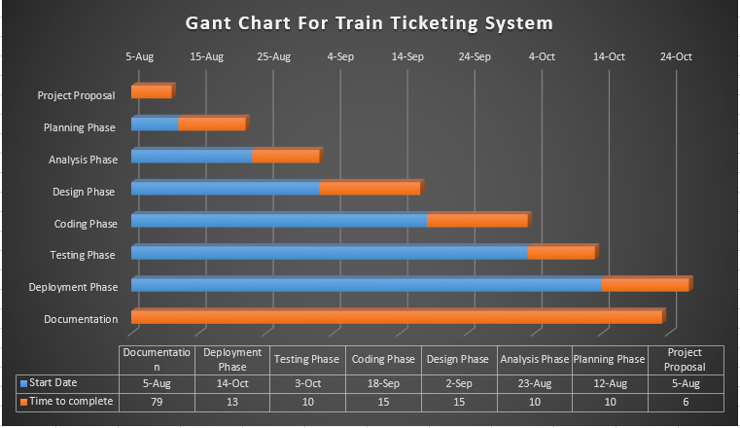

**Chapter 2**

**Systems Analysis**

**2.1. Data gathering methodologies employed**

Different data gathering methodologies were employed in the process of extracting information from different users during our planning and requirements gathering process in trying to understand how the current system works and how we can improve the system. Data gathering process is of higher importance in that it enables the developers to clearly understand how the current system is working be able to identify areas of concern or areas that need improvement. During our data gathering process we managed to employ the following methodologies.

**2.1.1*. Interviews***

* One on One interviews were used as they are an interactive method of data gathering and are very effective as one gets to also use body language to gather the unspoken words. Interviews also are a fast way of gathering data as one gets immediate feedback. We did ask question to some of the National Railways of Zimbabwe workers pertaining to the current Train Ticketing system efficiency and effectiveness and areas which need improvements. These interviews were carried out in both structured and unstructured manner.

**2.1.2. *Feasibility study***

* Feasibility study of other recent studies of the existing system and the possibility of replacing them helped me in the outlining the requirements details. The advantage with this methodology was that it helps in transfer of relevant details to the requirements specification.

**2.1.3. *Observations***

* Observing or shadowing helped me in providing information of existing processes, inputs and outputs. It was useful in that sometime the user might not be able to clearly explain that they do or their requirements for the new system. Adding on it was effective in the sense that it helps in noticing areas of improvement when developing the new system since the observing process will done either within the environment or from a distance.

**2.1.4.** ***Questionnaires***

* Questionnaires were useful for obtaining limited system requirements details from users, stakeholders who have a minor input. They were cost effective in that we managed to send many hundreds which was good for getting input from different stakeholders with different views and also it saved time. The questionnaires were distributed to the current system users or tellers, passengers and operations managers.

***Figure 2.1 : Questionaire Sample***

|  |  |  |
| --- | --- | --- |
|  | **QUESTIONAIRE ABOUT THE CURRENT MANUAL SYSTEM** |  |
| System analyst : Ignatious Mugwagwa | | |
| System for : National Railways of Zimbabwe | | |
| **Instructions**  1. You are advised to only give one response for each question.  2. If you agree with the question place a tick else you may place a cross. | | |
| **Questions**   |  |  | | --- | --- | | YES | NO | |  |  | |  |  | |  |  | |  |  | |  |  | |  |  |  1. Is the system time consuming? 2. Is it easy to search files? 3. Is it easy to access information? 4. Is there any backup for your system? 5. Do you know how to use a computer? 6. Is the manual system secure? | | |

**2.2. Description of existing system.**

National Railways of Zimbabwe currently uses manual and online ticketing systems. The problems with the manual ticketing system (book ticketing system) mainly is that it takes a lot of time in serving clients, there data redundancy, difficult in accessing data and or transaction records and lastly unsatisfactory security measures

This current book ticketing system has been in use since 1980 after the establishment of the National Railways of Zimbabwe from the Rhodesia Railways Company. Besides the book ticketing system National Railways of Zimbabwe has managed to implement the online train ticketing system which is currently in use.

The problem with the online ticketing system is that it does not cater for the illiterate passenger in remote areas of Zimbabwe, the system is also expensive to customers and or passengers in the sense that they do require to access internet to be able to do the reservation process and the process is time consuming since you can only reserve a ticket but not purchase the travelling ticket. Also due to geographical factors local clients in some remote areas of Zimbabwe cannot access the internet to do the ticket reservation process.

**2.3. Activity diagram**

Activity diagram is used to denotes the structural flow of the activities in the form of flow chart with decision boxes enhanced and hence is also used for troubleshooting like raising exceptions when a particular action is done and the alternative to be done when something abnormal is done. Thus the below activity diagram illustrates the structural flow of the activities that will be done when using the new Train ticketing system.

***Figure 2.2:*** *Activity Diagram*

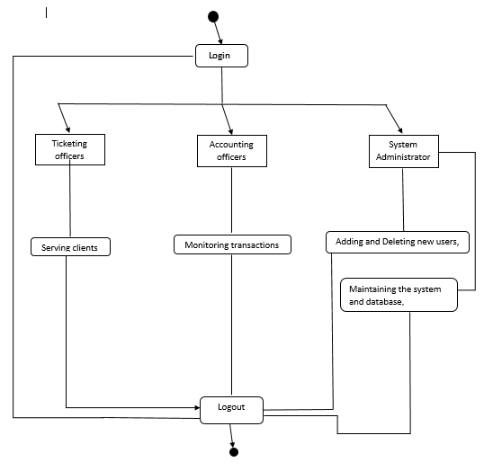

**2.4. Data Flow Diagram and Context Diagram**

***Figure 2.3:*** *Data Flow Diagram for the Current System*

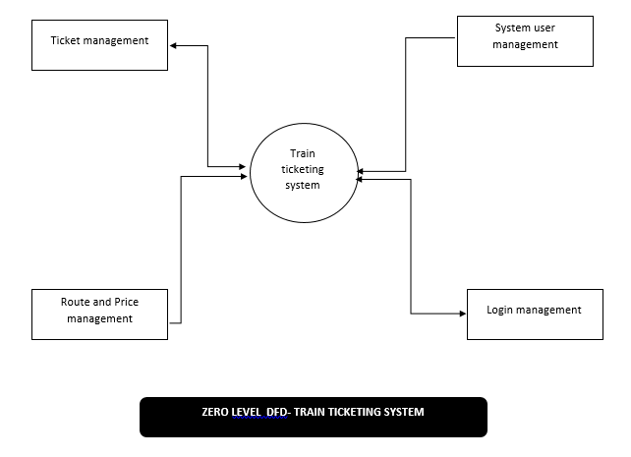

***Figure 2.4:*** *Context Diagram for the Current System*

Tellers & Travellers

Tickets as output

Train Book Ticketing system

The diagram shown above is a Context Diagramfor the Current Train Book Ticketing system in which we have summarised the whole process that is currently being provided by the system. It is a basic overview of the whole system. The Context Diagram illustrates the three basic components that are found in the proposed Train ticketing system which are the inputs, the processing unit and the outputs that will be produced by the system.

## **Weakness of existing system**

* The current book ticketing system mainly promotes poor service delivery in the ticketing process.
* The book ticketing system records can easily be destroyed in case of fire outbreak and water.
* The current book ticketing system is not secure since tellers and clients can make fake travelling tickets.
* The current online ticketing system is complex to use to clients in remote areas in Zimbabwe.
* The current online ticketing system is also expensive to the client for them to order ticket since there is need to connect to the internet.

## **Justification of alternative taken**

The new train ticketing system will have a lot of benefits to National Railways of Zimbabwe since the development of such a system will help in reducing the stated problems currently being faced by the organization (NRZ). Thus the alternative taken is technically, financially and operationally feasible.

Adding on the alternative will improves service delivery in the ticketing process since the process will be computerised which help in reducing work load to the workers and thus the system will help in safeguarding transaction records due to the implementation of database.,

The alternative system is secure since it will be able to monitors each and every transactions and also the system will be generating unique tickets which reduce case of using fake tickets. The security of the system will be implemented by the user of login process in which each and every user will be given login details he/she will be using to operate the system.

The alternative system will also cater for clients in remote areas of Zimbabwe since they can purchase travelling tickets at railway stations and reduce unnecessary cost of purchasing travelling ticket to clients since there will be no need to connect to the internet.

The advantage with the proposed system is that it enables to reduce error in the ticketing process, it eliminated the need of more main power, faster response time in serving clients and lastly reduction in use of paper.

* 1. **Requirements Analysis (Use Case Diagrams)**

Requirements analysis can easily be explained or described by the use case diagrams. Use case diagram comprises of use cases and actors such that there would be various kinds of relationships among the use cases and the actors. A use case diagram shows all the actions that a particular actor needs to perform throughout the system at every and any point of time. The proposed Train ticketing system will have mainly four actors that will be doing different activities in the system. These actors include the traveller, ticketing officer, accounts officer and lastly the system administrator.

* + 1. **Actors**

***Traveller***

* Orders a ticket
* Provide the destination details
* Pay fares
* Receive a ticket

***Ticketing Officer***

* Login
* Input traveller details
* Accepts traveller fare
* Prints traveller’s ticket
* Issues a ticket to the traveller

***Accounts Officer***

* Monitors transaction records
* Track all transaction records
* Creates financial record using the transaction records

***System Administrator***

* Creates user accounts
* Delete user accounts
* Monitors and maintain the database
* Update the database
* Maintains the whole system

***Figure 2.5 :*** *Use Case Diagram For The System*

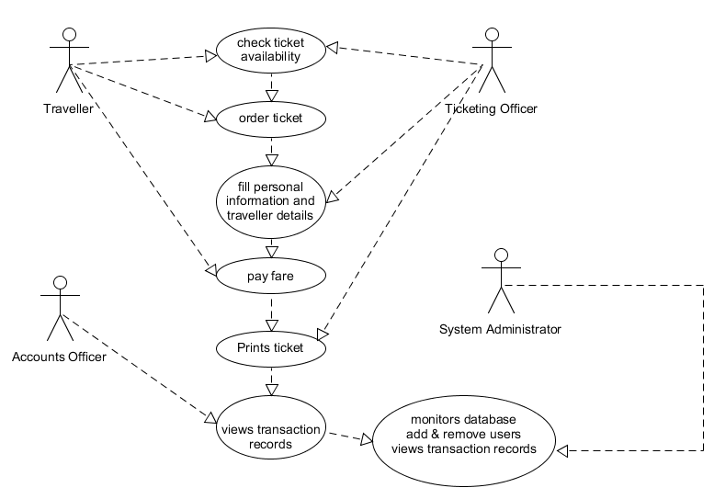

The diagram shown above is a Use Case Diagramfor the proposed Train Ticketing system in which we have illustrated the whole activities that will be done by the system actors. It is a detailed overview of the whole system. The Use Case Diagramshows all the actors and their duties they do in the system as explained above.

# **Chapter 3**

# **System Design**

## **Proposed systems DFDs (Context and Detailed)**

Train ticketing system data flow diagrams are mostly used to create an overview of the system without going into greater detail which will later be explained. It consists of overall system dataflow and processes of the train ticketing process. It also contains all the user flow and their entities such as the flow of customer details, train route, payment and ticket. All the data flow diagrams below have been used for the purpose of visualization of data processing and structure of the Train ticketing process and work flow. The DFD may be used to represent a system or software at any level of abstraction. Data flow diagrams may be partitioned into levels that represent increasing information flow and functional detail.

**Figure 3.0:** *Context Diagram for the system:*

Output

User/Admin/Accounts officers

Train Ticketing system

The diagram shown above is a Context Diagramfor the proposed Train Ticketing system in which we have summarised the whole process that will be done by the system. It is a basic overview of the whole system. The Context Diagram illustrates the three basic components that are found in the proposed Train ticketing system which are the inputs, the processing unit and the outputs that will be produced by the system.

**Figure 3.1:** *Level – 0 Data Flow Diagram*



The diagram shown above is a zero level DFD of the Train Ticketing system in which we have elaborated the high level process of the Train ticketing system. It is a basic overview of the whole system. The zero level illustrates the entities that are connected to the train ticketing system and these entities include the ticket management, route, price, login and system user management.

**Figure 3.2:** *Level – 1 Data Flow Diagram*

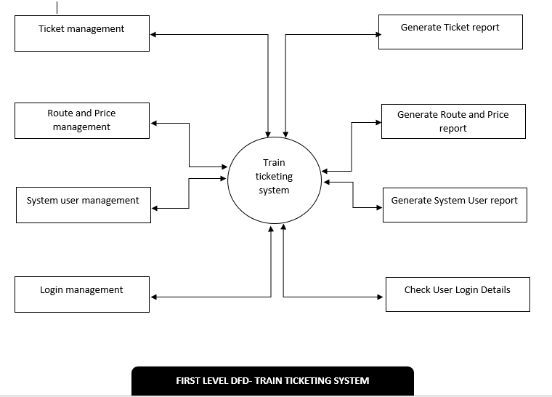

A level 1 DFD is the further refinement of level 0 DFD showing greater details and functionalities. In this, the single bubble of level 0 DFD is refined further. Each of the processes depicted at level 1 is a sub function of the overall system depicted in the context model. The first level DFD identifies internal data stores of different entities and the entities that must be present in order for the system to do its job and also it shows the flow of data between the various parts of the system.

**Figure 3.3:** *Level – 2 Data Flow Diagram*

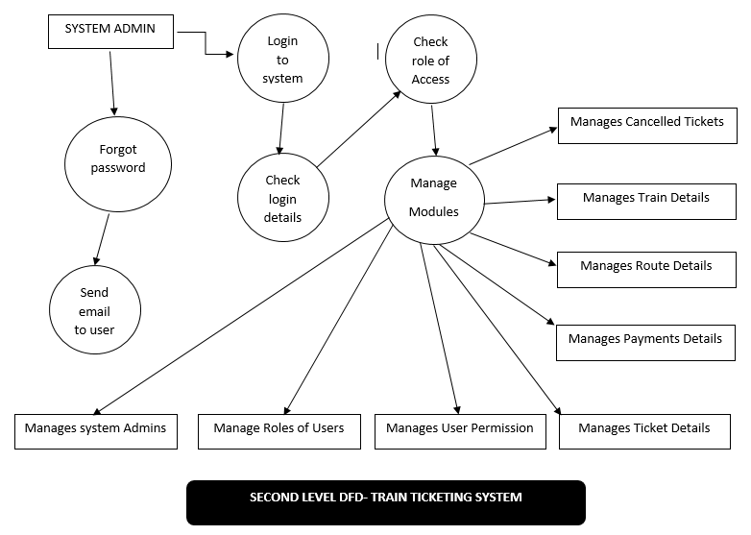

The above diagram illustrates a level 2 DFD is the further refinement of the level 1 DFD. DFD level 2 then goes one step deeper into the parts of level 1 of the Train Ticketing System. It requires more functionalities of the Train Ticketing system to reach the necessary level of detail about the Train Ticketing process. First level DGFD of the Train Ticketing system shows how the system is divided into sub system or processes while the second level DFD contain more specific details.

## **Architectural design**

The Train Ticketing System was designed using the client-server architecture. The main reason behind this design of a client-server computing architecture is that transport organisations such as the National Railways of Zimbabwe will effectively increase its productivity through the usage of cost-effective user interface, enhanced data storage, vast connectivity and reliable application services.

Client-server architecture enables easy data sharing that is data is retained by usual business processes and manipulated on a server is available for designated users (clients) over an authorized access. In this client-server architectural design there will be different types of authorized clients that will be using the system. These clients include the ticketing officers, accounting officers and lastly the system administrators as it can be illustrated below:

**Figure 3.4:** *Client-Server Architecture Design Diagram*

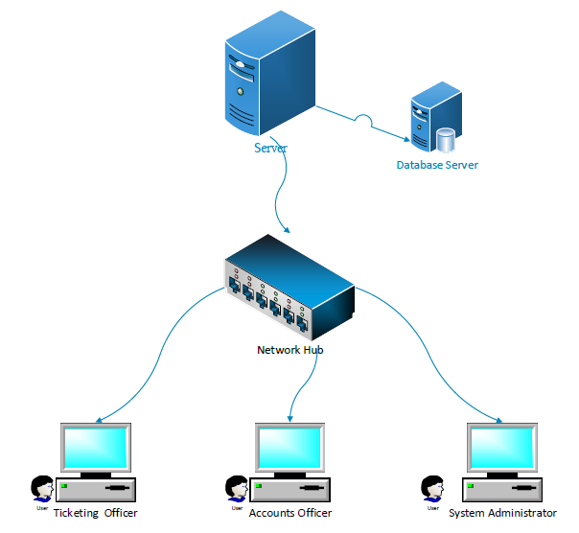

**3.2.3 *Advantages of the Client-Server Architectural Design***

Client-server architecture design allows interaction of clients on a daily basis such as the services that will be provided by the Proposed system in transportation sector services.

Secondly the Client-server architectural design enables reliable application services between the client and the service such as Ticketing process this is because the architecture type allows direct interaction between the client and the server which also reduce traffic in the delivery of services.

Client-server architectural design promotes security which is of higher importance to have in that servers have better control access and resources to ensure that only authorized clients can access or manipulate data and server updates are administered effectively.

The client-server architectural design allows integration of services which then result in every client being given the opportunity to access corporate information via desktop interface eliminating the necessity to log into a terminal mode.

The architectural design is also easy to maintenance in that client-server architecture is distributed model representing dispersed responsibilities among independent computers integrated across a network. Therefore, it's easy to replace, repair, upgrade and relocate a server while client remains unaffected. This unaware change is called as Encapsulation.

## **Menu Design**

The different Menu’s in the system include:

* + 1. **Login Menu**

Only the authorized users can login into the system. Admin, Accounts officer and Ticketing officer can login using their username and password. If invalid username or password is given, then access will be denied. The log in menu is shown on the next page.

**Figure 3.5:** *Login Menu*

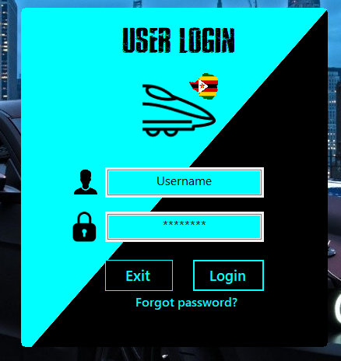

* + 1. **Administration Menu**

The administrator can add new users as well as change their password of the users. The administrator is also able to view transactions. The administrator menu is illustrated on the next page:

**Figure 3.6:** *Administration Menu*

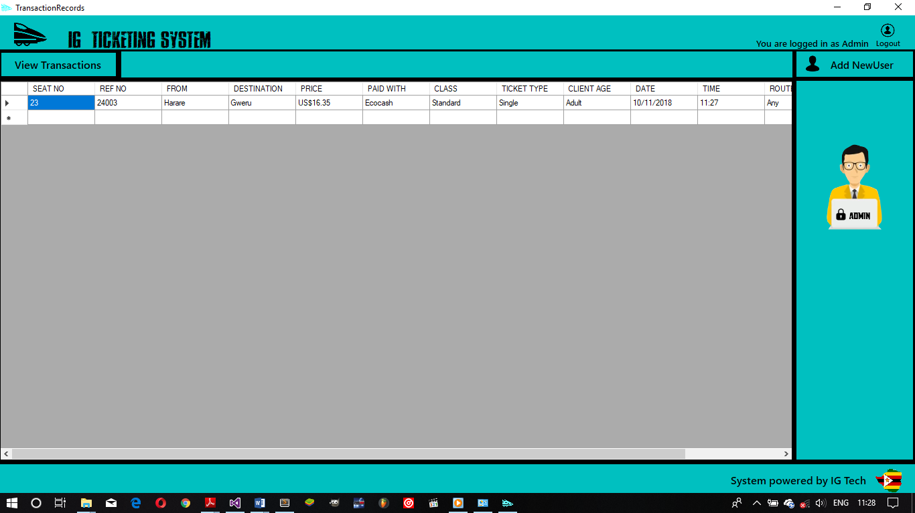

* + 1. **Accounts Menu**

The Accounts officers or the finance department are able to view all the transaction that will be done during the working hours. The Accounts officers are also able to view the name of the Ticketing officer, date and time of the transactions, and lastly the form of payment used to pay for tickets by passengers. The accounts menu is shown on the next page:

**Figure 3.7:** *Accounts Menu*

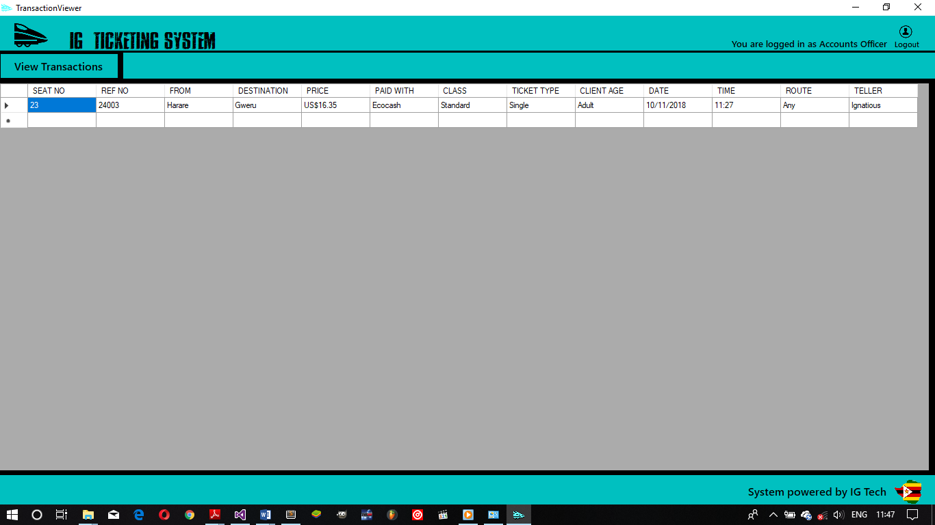

* + 1. **Ticketing Officer Menu**

The menu is one of the main menu of the whole train ticketing system in that that’s where all ticketing process will be done by the ticketing officers. The menu is shown below in figure 3.8:

**Figure 3.8:** *Ticketing Officer Menu*

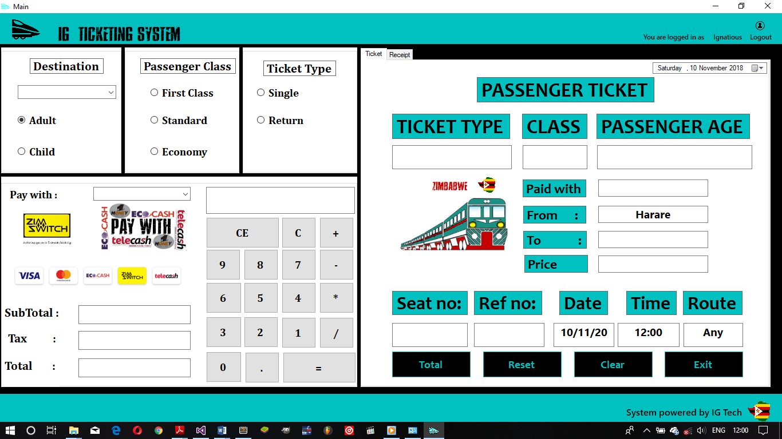

## **Input design**

The input designs for the system are as follows:

***Login menu*:**  the Login menu accepts username and password as inputs that will authenticated in which if the inputs are correct the user is given access to the system were as if the inputs are wrong the user will be denied access to the system. The input design for the Login menu can be shown on the next page:

**Figure 3.9.** *Login input design*



***Administrator menu*:**  the administrator inputs user id, username, password and gender which will be stored in a database allowing users to gain access into the system. The input design for the administrator can be shown on the next page:

**Figure 3.10** *Administrator input design*

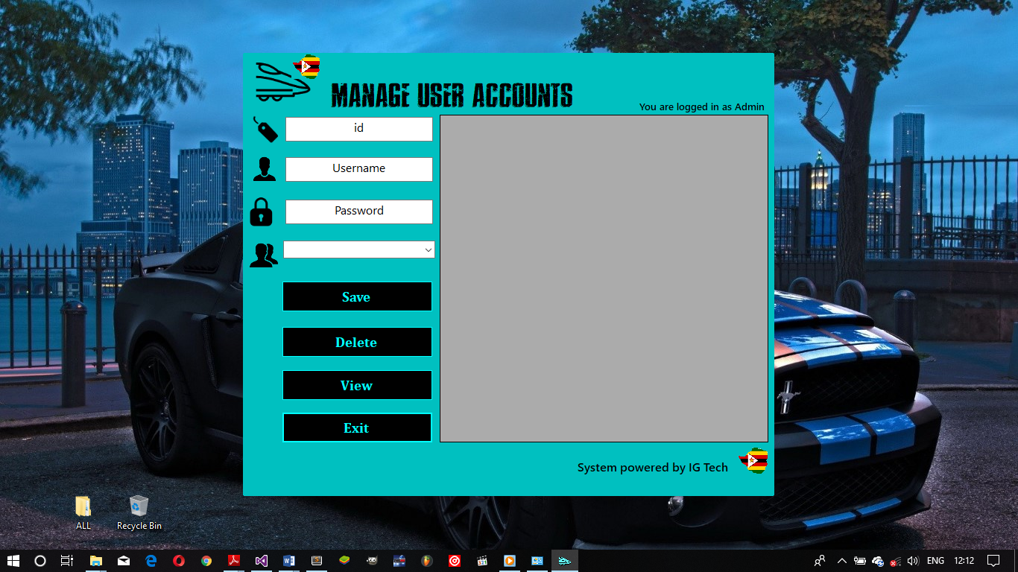

***Ticketing Offer*:**  the Ticketing officer inputs passenger destination, passenger class, passenger age, passenger ticket type and lastly the form of payment used by the passenger which will be processed to calculate the price and then information will be stored in a database allowing the admin and accounts officer to view the transaction details. The input design for the Ticketing office can be shown on the next page:

**Figure 3.11.** *Ticketing officer input design*

**

## **Output design**

The output design for the system are as follows:

***Administrator* *menu:*** the output design for the administrator mainly will be showing the transaction history and the details of the user id, username, password and gender which are accessed directly from the database. The admin output design are shown below:

**Figure 3.12** *Output menu for the System Administrator*



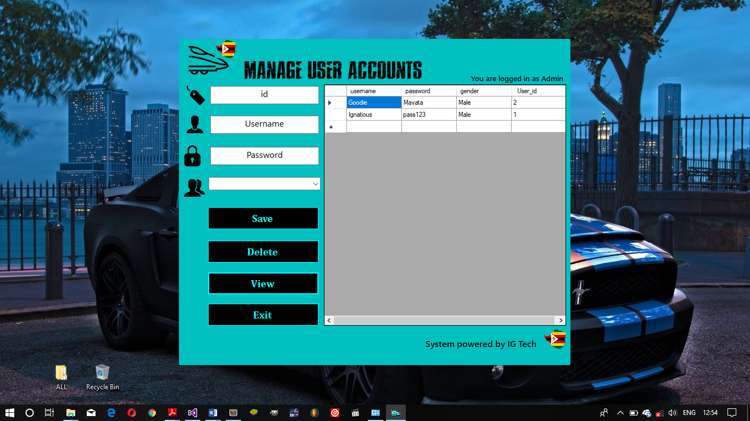

***Ticketing* *menu:*** the output design for the Ticketing menu mainly will be showing the following items:

* Passenger destination
* Passenger age
* Passenger ticket class
* Passenger ticket type
* Amount paid
* Form of payment used
* Time and date

The output design for the Ticketing menu is shown below:

**Figure 3.13** *Output design for Ticketing Menu*

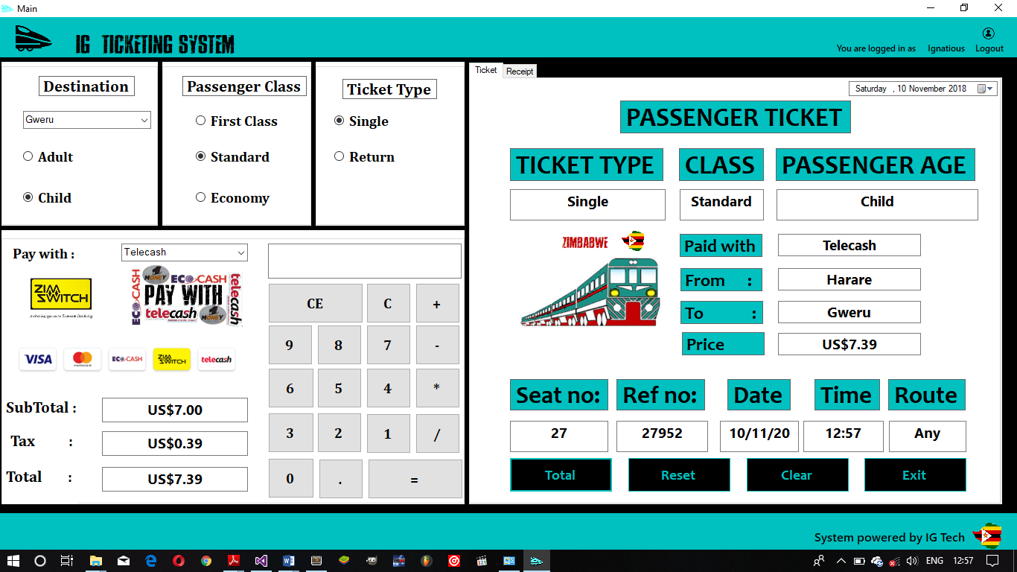

## **Process design (Pseudo code, Flow charts)**

The Proposed system is composed of the login and ticketing process designs. The process designs can be illustrated on the next page in form of pseudo codes and flow charts. The program flowchart shows how the system proceeds from the input form to the output form of the system. It explains how the system is actually processed step by step. It represents the flow of control as the system is processed.

* + 1. **Pseudo code for Ticketing process**

Start

Enter Traveller’s details

Verify Traveller’s details

Capture details

Enter form of payment

Print receipt

Issue receipt

Stop

* + 1. **Pseudo code for Login process**

Start

Enter Username

Enter Password

Verify User input details

if username and password is correct

Proceed to Next form

Else re-enter Username and Password

Stop

* + 1. **Flow Chart for Login process**
    2. **Flow Chart for Ticketing process**

## **Database design (DD, ER and EER diagrams)**

## **Program design (Class, sequence, collaboration, package)**

## **Test data design**

## **Security and Backup design**

## **Test data design**

## **Deployment diagram**